**REST API call to**

**Get Weather and Wind Updates from**

**A Weather API Service**

Contents

1. Overview of REST
2. API call to get current weather at Wylie
3. API call to get Wind conditions at Wylie
4. Final output

**Overview of REST**

* REST APIs are different from its predecessor SOAP.
* An API is an interface between two systems, how they communicate and interact with each other.
* Web services use HTTP protocol for communicating request and responses.
* They are language agnostic and work on any platform for communication.
* When a system makes a request, a response is generated.

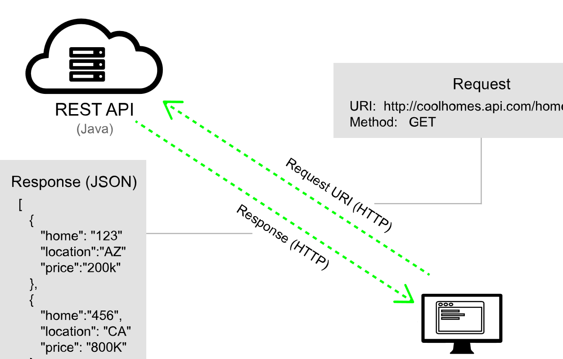

Source: <https://idratherbewriting.com/learnapidoc/docapis_what_is_a_rest_api.html>

**REST API call to get weather conditions of a place with a zip code.**

GET: "https://api.openweathermap.org/data/2.5/weather?zip=75098&units=imperial&appid=2ac115d3bf152bd58d446dcf3b07ea55",

Input param- API key and the zip code of the place.

Response- JSON object

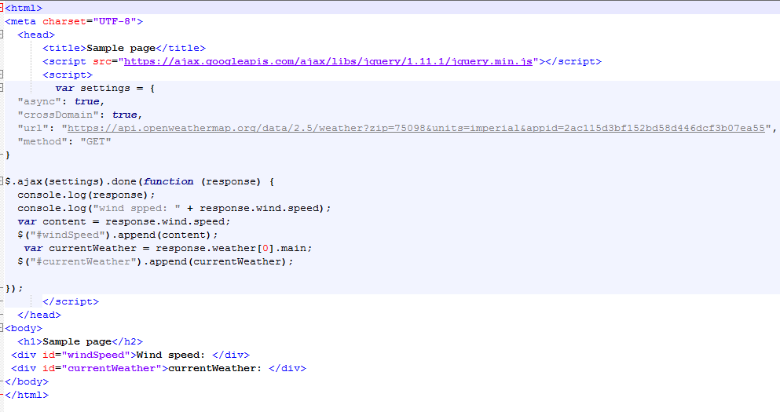

**REST API call to get wind conditions of a place with a zip code and country code.**

GET: "https://api.openweathermap.org/data/2.5/weather?zip=75098,us&appid=fd4698c940c6d1da602a70ac34f0b147&units=imperial",

Input param- API key and the zip code of the place and the country code.

Response- JSON object

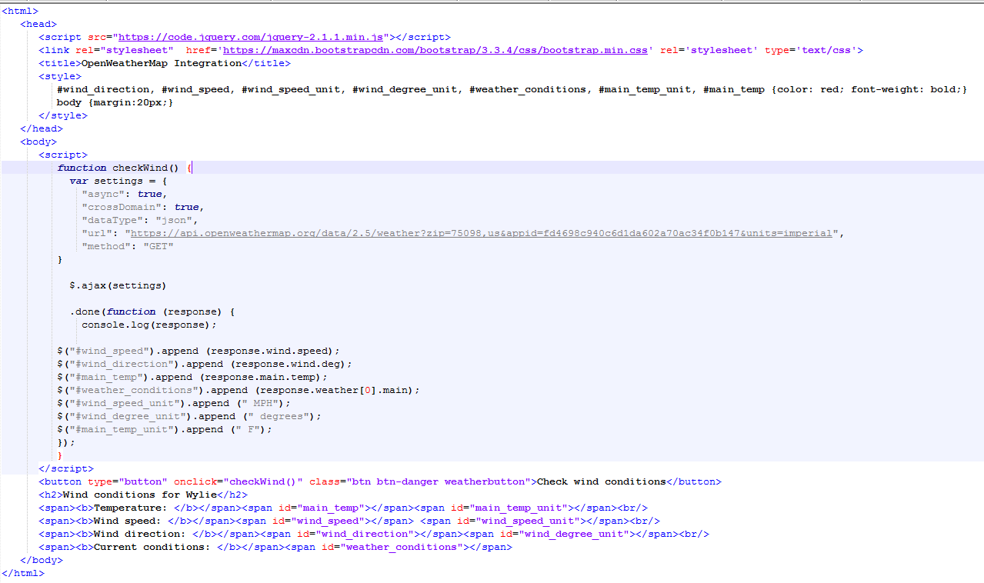

**When you open the browser and run the HTML file, the below page is loaded.**

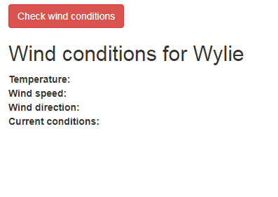

**Fig: Before button click of Check wind conditions**

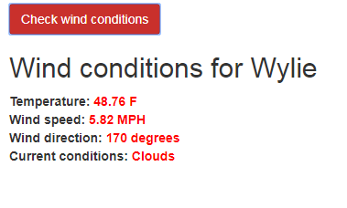

**Fig: After click of the button**